**ASSIGNMENT 1:**

**Build a smart home in tinker cad, use at least 2 sensors, led, buzzer in a circuit.**

**Simulate in a single code.**

**CODE:**

// C++ code

int IR = 0;

int IR2 = 0;

void setup()

{

pinMode(2, INPUT);

pinMode(4, INPUT);

Serial.begin(9600);

pinMode(13, OUTPUT);

pinMode(LED_BUILTIN, OUTPUT);

}

void loop()

{

IR = digitalRead(2);

IR2 = digitalRead(4);

Serial.println(IR);

Serial.println(IR2);

delay(10); // Wait for 10 millisecond(s)

if (IR2 <= IR && IR2 >= IR) {

digitalWrite(13, LOW);

digitalWrite(LED_BUILTIN, LOW);

} else {

digitalWrite(13, HIGH);

digitalWrite(LED_BUILTIN, HIGH);

}

}

**CIRCUIT DIAGRAM:**

**LIGHTS ON, BUZZER ON:**

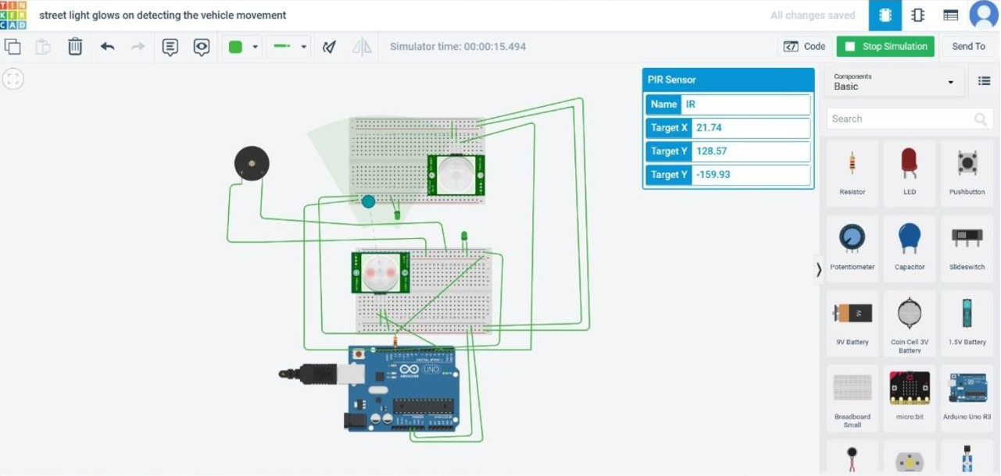

**LIGHTS OFF, BUZZER OFF:**

